OCCUPATIONAL DRIVER’S LICENSE INFORMATION

This packet contains information regarding eligibility for an occupational driver’s license and step by step instructions on how to file for an occupational driver’s license.
You must complete the following IN THIS ORDER:

- Complete the Petition and affidavit.
- Order a certified Abstract of Driving Record (Type AR). Certified Driver’s History from https://txapps.texas.gov/tolapp/txldrcdr/TXDPSLicenseeManager Please make sure you order the correct one. There are several types, be certain that it is the Complete Abstract of Driving Record History (Type AR).
- Go to your vehicle insurance company agent and ask for an SR-22. You will need this before you can file your case.
- Once you have received your certified abstract of driving record and SR-22, take the completed Petition, the Waiver and the Notarized Affidavit to: Assistant District Attorney, One East Main, Bellville, TX 77418. They will review your case. If all paperwork is in order, the Assistant District Attorney will then instruct you to file the case in the proper court.
- To file your case, you must have the Petition, Affidavit, SR-22, Abstract Driving History, signed waiver and filing fee of $54.00 (only payable by exact cash, cashier’s check or money order made payable to Austin County JP #4).
- You will be given your hearing date at time of filing.
- If the Court approves an Order for Occupational License, there will be an additional fee of $30.00 for certified copies. (only payable by exact cash, cashier’s check or money order payable to Austin County JP #4)

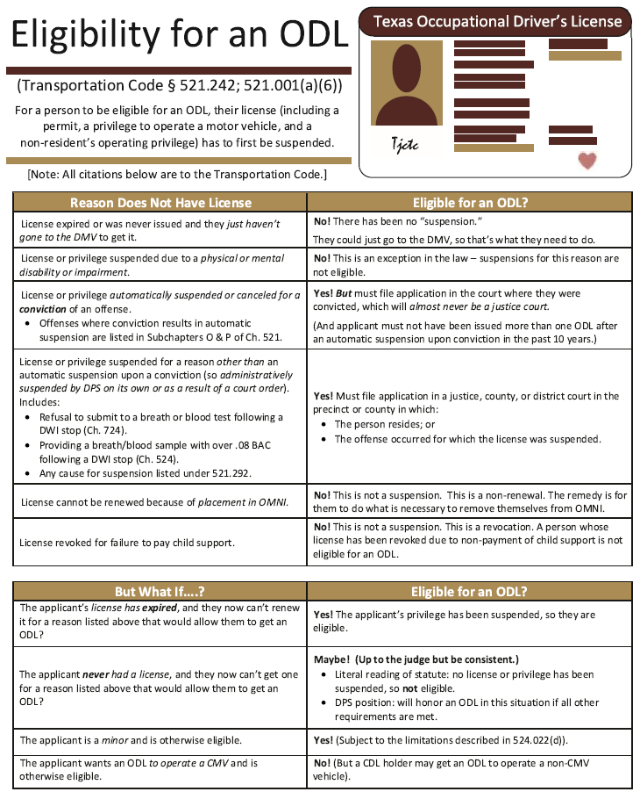

CAUSE NO. ____________________

EX PARTE | § | IN THE JUSTICE COURT
 | § | PRECINCT NO. 4
PETITIONER’S NAME | § | AUSTIN COUNTY, TEXAS

PETITION FOR OCCUPATIONAL LICENSE

I, __________________________________________, seek an occupational license from this court based on the information provided below. (You must swear that the information you provide in this petition is true and correct. Failure to provide true and accurate information may result in criminal penalties.)

Section 1. General Information.
My name is: ___________________________________________________________________________
My date of birth is: ________________________________
I am a resident of __________________________________ County, Texas.
My home address is: ____________________________________________________________________
My mailing address (if different than above) is: ______________________________________________
My Texas driver’s license number is: ___________________________________________________
- I am employed, and my occupation is ________________________________________________
- I am the primary caretaker of ________ children less than 16 years of age.
- I have been ordered by a magistrate to install an ignition interlock device on my vehicle, and/or not to operate any vehicle which is not equipped with an ignition interlock device.

Section 2. Reason(s) for Driver’s License Suspension.
- My driver’s license has been suspended for the following reason, described below:
________________________________________________________________________________________________________________________________________________
Section 3. Essential Need.
(Note: In order to obtain an occupational license, you must demonstrate an essential need to operate a motor vehicle. The Texas Transportation Code defines “essential need” as the “need of a person for the operation of a motor vehicle: (A) in the performance of an occupation or trade or for transportation to and from the place at which the person practices the person's occupation or trade; (B) for transportation to and from an educational facility in which the person is enrolled; or (C) in the performance of essential household duties.” In order to demonstrate an essential need to operate a motor vehicle, you may attach additional documentation, such as a letter from your employer. If you attach additional documentation, be sure to check the appropriate box in Section 5 of this petition.)
- I am seeking this occupational license in order to (check all that apply):
  - Travel to and from my place of work;
  - Perform the duties of my job;
  - Travel to and from school; or
  - Perform essential household duties.
- My work or school schedule is the same every week: I work or attend school during the following hours on the following days of the week (check all that apply):
  - Monday: __________________________________________________________________
  - Tuesday: __________________________________________________________________
  - Wednesday: __________________________________________________________________
  - Thursday: __________________________________________________________________
  - Friday: __________________________________________________________________
  - Saturday: __________________________________________________________________
  - Sunday:___________________________________________________________

- List all Counties you will be required to travel by vehicle for work or school. My work or school schedule varies from week to week. (If you check this box, provide a general description of your work or school schedule below, including the total number of hours you work or attend school each week, days of the week on which you never work or attend school, days of the week on which you always work or attend school, and the earliest time your work or school day begins and the latest time your work or school day ends.)
________________________________________________________________________________________________________________________________________________________________________________________________________________________

- My job duties include automobile travel. My employer requires me to travel by automobile to perform the following tasks:
________________________________________________________________________________________________________________________________________________

- I perform the following essential household duties:
________________________________________________________________________________________________________________________________________________

Section 4. Suspension History
My driver’s license has previously been suspended for:
- A second or subsequent conviction for Driving While Intoxicated (Section 49.04, Penal Code); Intoxication Assault (Section 49.07, Penal Code), or Intoxication Manslaughter (Section 49.08, Penal Code), committed within five years of a previous conviction for Driving While Intoxicated (Section 49.04, Penal Code); Intoxication Assault (Section 49.07, Penal Code), or Intoxication Manslaughter (Section 49.08, Penal Code).
In the past five years, my license has been suspended for:
- A refusal to submit to the taking of a breath or blood specimen following an arrest for an offense prohibiting the operation of a motor vehicle or an offense prohibiting the operation of a watercraft while intoxicated, under the influence of alcohol, or under the influence of a controlled substance.
- An analysis of a breath or blood specimen showing an alcohol concentration of .08 or above, following an arrest for an offense prohibiting the operation of a motor vehicle or watercraft while intoxicated.
- A conviction for Driving While Intoxicated (Section 49.04, Penal Code); Intoxication Assault (Section 49.07, Penal Code), or Intoxication Manslaughter (Section 49.08, Penal Code).
- A conviction for an offense other than Driving While Intoxicated (Section 49.04, Penal Code); Intoxication Assault (Section 49.07, Penal Code), or Intoxication Manslaughter (Section 49.08, Penal Code) prohibiting the operation of a motor vehicle or watercraft while intoxicated, under the influence of alcohol, or under the influence of a controlled substance.

Section 5. Additional Documents.
- I have obtained evidence of financial responsibility, which is attached to my petition. (Note: You may not be issued an occupational license unless you obtain evidence of financial responsibility.)
- I have attached a certified copy of my driving record to this petition. (Note: the court cannot grant your petition without reviewing your driving record.)
- I have attached documents which demonstrate my essential need to operate a motor vehicle.
- I have attached other documents, which are described below:
________________________________________________________________________________________________________________________________________________

PRAYER

WHEREFORE, PREMISES CONSIDERED, Petitioner prays that this Honorable Court grant this Petition for Occupational License, and to send a certified copy of this Petition, along with its order granting petitioner’s occupational license to the Texas Department of Public Safety.

_________________________________________
Petitioner’s Signature

SWORN TO AND SUBSCRIBED before me on this ____ day of _______________________, 20_____.

__________________________________________________
Clerk of the Justice Court or Notary

CAUSE NO. ___________________________

EX PARTE | § | IN THE JUSTICE COURT
 | § | PRECINCT NO. 4
PETITIONER’S NAME | § | AUSTIN COUNTY, TEXAS

WAIVER

TO THE HONORABLE JUDGE OF SAID COURT:
Now come the District Attorney of Austin County, Texas, the attorney for the state and after having been furnished a copy of Petitioner’s Petition for Occupational Driver’s License, by these presents expressly waives notice as otherwise required by law.

SIGNED ON: __________________________

Assistant District Attorney
One East Main, Bellville, Texas 77418
Austin County, Texas
Signature By: _____________________________
Print Name: _____________________________
Assistant District Attorney
Austin County, Texas
State Bar No.__________________________

Attest: Court Clerk
By: ______________________________
Court Clerk

